國小組試題

【說明】

一、答案卡不可做任何記號

二、請按題次作答，將正確答案畫在答案卡題號上

三、請用2B鉛筆，可用橡皮擦修改，不可用立可白塗改

壹、聽力測驗：本測驗共有20題，每題1分。請根據聽到的內容選出最適當的答案，每題有A、B、C、D四個選項

Part I.

Look at the pictures below. For each, you will hear two questions and four possible answers, A to D. Then choose the best answer.

For questions 1 and 2, please look at picture A.

**A.**

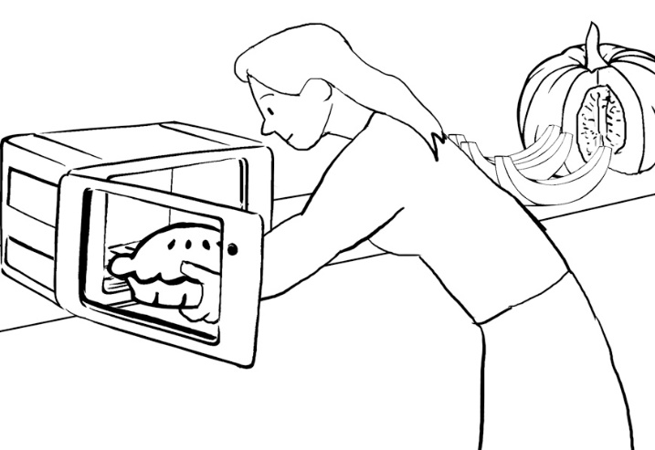

For questions 3 and 4, please look at picture B.

**B.**

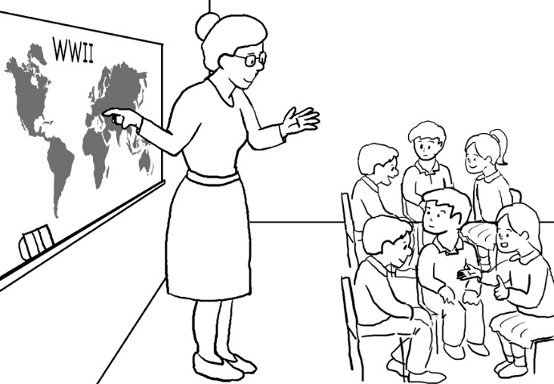

Part II. *Listen to the question or statement and choose the best response.*

1. 【Listen】

(A) I don’t like their flavor either.

(B) I really enjoy eating them, too.

(C) I know strawberries are one kind of fruit.

(D) I know children like to eat ice cream often.

1. 【Listen】

(A) I know you don’t want to keep it anymore.

(B) I know you just bought it from the store.

(C) I know you didn’t mean to hurt it.

(D) I know you didn’t want a puppy.

1. 【Listen】

(A) No, he hasn’t decided yet.

(B) Yes, he fired me yesterday.

(C) Sure, he has finished the report.

(D) No, he doesn’t like the new worker.

1. 【Listen】

(A) Yes; he’s always using that tool.

(B) I don’t know when he bought his phone.

(C) No wonder his phone bill isn’t very expensive.

(D) He is not as interested in taking photos as he used to.

1. 【Listen】

(A) The lemon pie made me feel sick.

(B) The lunch is served until 2:00 pm.

(C) I once had the chocolate cake here.

(D) Many people like the cheeseburger.

1. 【Listen】

(A) It helps me to read at night.

(B) It is the light from the evening sun.

(C) It tells you when your battery is low.

(D) It is difficult to see the light on cloudy days.

1. 【Listen】

(A) Sure, I’m leaving in the morning.

(B) Well, I’ll pick you up there at 11:00 sharp.

(C) I’ll wake up at 11:00 in the morning.

(D) The 11:00 flight to New York will be delayed.

1. 【Listen】

(A) OK; I’ll tell you how to say it.

(B) I don’t know how it should be used.

(C) Sure; I can show you how to write it.

(D) Of course. I can tell you how to look it up.

1. 【Listen】
2. He must be successful.
3. He can try listening to music.
4. Taking painkillers is a good idea.
5. It is common practice for everyone.
6. 【Listen】

(A) No, yours is more delicious than mine.

(B) Yes, let’s grab something new for lunch.

(C) Sure, let’s eat something besides sandwiches.

(D) OK, you can have mine, and I’ll have yours.

1. 【Listen】

(A) Why don’t you have many problems?

(B) Well, they won’t go away on their own.

(C) So, you think I also have these problems.

(D) You are so stupid that you’ll be a troublemaker.

1. 【Listen】

(A) What kind of product is that?

(B) I’m sorry you went out of business.

(C) I want to know why you’re losing cash.

(D) I’m happy that you’re making money.

1. 【Listen】

(A) I’m trying to get a new job.

(B) You don’t like this dress.

(C) It looks gorgeous on you.

(D) I will go jogging in the park.

Part III.  *Listen to the following paragraph and answer the questions*

1. 【Listen】
2. Why the speaker loves Thanksgiving.
3. The speaker’s Thanksgiving last year.
4. How to prepare Thanksgiving dinner.
5. What the speaker eats on Thanksgiving.
6. 【Listen】

(A) How her uncle’s hair caught on fire.

(B) How the turkey was burnt in the oven.

(C) How her uncle ate all the pumpkin pie.

(D) How her mom bought some new candles.

1. 【Listen】
2. The speaker.
3. The speaker’s mom.
4. The speaker’s aunt.
5. The speaker’s uncle himself.

貳、字彙測驗：請按題意，選出最適當的答案，畫在答案卡上。21~35題，每題1分。

1. It is common __________ for Taiwanese people to give children red envelopes

during the Lunar New Year.

(A) action (B) point (C) habit (D) practice

1. The words in the dictionary are listed in alphabetical _____________.

(A) unit (B) order (C) place (D) set

1. Happiness __________ in contentment. People who are satisfied with what they have are usually happier.

(A) falls (B) ends (C) lies (D) turns

1. There is a bridge over the river, which is ___________ for people.

(A) constant (B) convenient (C) consistent (D) constructive

1. The teacher drew _________ to decide whose turn it was to answer the question.

(A) lots (B) tones (C) scenes (D) wills

1. There is no short cut to success. That is, it __________ time and effort to achieve goals.

(A) happen (B) appears (C) causes (D) takes

1. The leader made great ________ to put the plan into action. He tried hard to carry out the plan.

(A) measures (B) agreements (C) efforts (D) advances

1. Dylan: Why are you ____________?

Adele: I want to go backpacking, but my parents don’t agree.

(A) annoying (B) disappointed (C) fascinated (D) surprising

1. Why did she come to the States? What is the ____________ of her visit?

(A) purpose (B) statement (C) transportation (D) movement

1. Russian is a difficult language to ________. Few people can learn it well.

(A) master (B) reach (C) pursue (D) stand

1. The fortune-teller says that they are ___________ for each other. It means that they can be each other’s good husband or wife.

(A) meant (B) forced (C) raised (D) devised

1. Dr. Goodman has a high ___________ in society. Everyone respects him a lot.

(A) edge (B) class (C) level (D) position

1. Mary can speak English and Japanese, and now she is learning French. She is really interested in _________ languages.

(A) foreign (B) handsome (C) comfortable (D) expensive

1. The billionaire __________ a life of luxury. He wears brand-name clothes and drives sports cars.

(A) stays (B) shows (C) lacks (D) leads

1. Don’t jump to _____________, or you’re likely to make a wrong decision.

(A) experiments (B) explosions (C) conclusions (D) difficulties

叁、文法測驗：請按題意，選出最適當的答案，畫在答案卡上。36~51題，每題2分。

1. In my family, my father is the one who __________ reading in his free time.

(A) enjoy (B) enjoys (C) enjoying (D) to enjoy

1. Visiting strange places often _________ people learn more about other countries.

(A) help (B) helps (C) helping (D) to help

1. ________ late for appointments. There must be something wrong with him.
2. Never Mark does (B) Never Mark is

(C) Seldom does Mark (D) Seldom is Mark

1. The hardworking salesperson tried to sell his product from one door to _________.
2. one (B) other (C) another (D) the other
3. ___________ the thorny situation, Tina turned to her parents for advice.
4. To handle (B) Handle (C) Handled (D) Handling
5. Mark has never been to Tromsø, a small town close to the Arctic Circle, ________?
6. does he (B) has he (C) doesn’t he (D) hasn’t he
7. Joshua looks down, so his friends really want to know ____________ yesterday.
8. what did he happen (B) what he happened

(C) what is happening to him (D) what happened to him

1. Our English teacher, Mr. Biden, made the term paper __________ in plain English.
2. written (B) to be written (C) write (D) to write
3. Over the last decade, the Internet _____________ the way people live their lives.
4. has changed (B) had changed (C) changes (D) changed
5. It is not good luck, but hard work ____________ attains the goals one sets.
6. who (B) that (C) what (D) when
7. I ____________ a hamburger and French fries for lunch every day last week.
8. eat (B) ate (C) has eaten (D) had eaten
9. When Pete ___________ to Taipei next month, I’ll take him around to see something interesting.
10. will come (B) has come (C) was coming (D) comes
11. There is something wrong with my computer, but I don’t know ____________.
12. how to fix (B) what to do it

(C) how to repair it (D) what to use them

1. _____________ some awkward questions, the sports icon said nothing but smile.
2. Asking (B) Asked (C) To ask (D) To be asked
3. Put on your face mask, _________ you’ll be likely to get COVID-19 virus.
4. and (B) but (C) or (D) also
5. I thought that Tom ___________ all of the household chores before he took a break.

(A) does (B) was doing (C) has done (D) had done

肆、文意選填：本測驗52~58題共有7題，每題3分。請按文意，選出最適當

的答案，畫在答案卡上。

In America, Halloween is one of the most popular holidays. It __52__ October 31 every year. Halloween is celebrated in different forms by people, children and adults ___53___. On that day, there is a majority of ghosts, vampires, and ghouls that pour out onto the streets. The children in costumes go from door to door in ___54___ of candy. Besides, adults throw costume parties and wear disguises ___55___ from witches and werewolves to mummies and zombies in celebration of this festival. Many people try their best to look horrible, some of ___56___ will wear black capes and wield saws and axes. With these costumes on, they look ___57___ and draw more attention. Still, there are people who choose to wear cute costumes ___58___ creepy ones. What disguises will you wear this year?

1. (A) lies in (B) puts in (C) holds on (D) falls on
2. (A) alike (B) as well (C) likely (D) or so
3. (A) honor (B) search (C) memory (D) support
4. (A) ranging (B) suffering (C) receiving (D) isolating
5. (A) them (B) whom (C) people (D) which
6. (A) more afraid (B) much feared

(C) even scarier (D)more frightened

1. (A) in addition to (B) according to (C) instead of (D) because of

伍、閱讀測驗：測驗59~61題共有3題，每題4分。請按文意，選出最適當的答案，畫在答案卡上。

When I was young, my favorite ride was a roller coaster called *The Pippin*. It was located in Memphis, Tennessee, and this ride was also a favorite of Elvis Presley, known as “King of Rock and Roll.” He would often rent out the entire park and ride the Pippin over and over again. It was old and noisy, and always seemed a little dangerous and rickety. That’s why I loved it! I could ride the Pippin and safely experience fear and take risks.

That’s what attracts a lot of people to these types of rides. Roller coasters fool us into feeling like we’re in danger because they’re designed that way, but in fact these rides just seem more dangerous than they really are.

Many rides across the world fall into this category. Take for example, New Jersey’s *Kingda Ka*. At 139 meters tall, this is the world’s tallest coaster. The world’s fastest roller coaster reaches speeds up to 240 kilometers per hour. This is Abu Dhabi’s *Formula Rossi*. The world’s longest roller coaster is Japan’s *Steel Dragon 2000*, with 2,439 meters of track. Also in Japan, the *Do-Dodonpa* starts the quickest. Riders go from zero to 180 kilometers per hour in just 1.56 seconds. Taiwan’s *Gravity Max* has been called one of “the scariest roller coasters in the world!” It has a true 90-degree drop.

What does the future hold for roller coasters? Most likely, coaster designers will continue looking for new and creative ways to scare us.

1. In the first paragraph, the story of *The Pippin* is used to ________________.

(A) promote the safety and excitement of the ride

(B) show that celebrities like to ride roller coasters too

(C) introduce a memory that guides the topic of the passage

(D) share with the readers the danger of the roller coaster

1. What is the main idea of paragraph 3?

(A) Examples of scary coasters around the world

(B) World records set by roller coaster engineers

(C) The history of roller coasters and their design

(D) Some ways to entertain ourselves in other countries

For question number 61, read the passage below that is directly connected to the topic of the passage above.

|  |
| --- |
| **The tallest roller coaster in the world is the Kingda Ka, a coaster in**  **New Jersey that launches its passengers from zero to 128 miles per hour in 3.5 seconds. It then heaves its riders upward at a 90-degree angle until it reaches a height of 456 feet, over one and a half football fields, above the ground, before dropping another 418 feet.** |

1. Which of the following images most closely matches the description in the passage above?

|  |  |
| --- | --- |
| **(A)** | **(B)** |
| **(C)** | **(D)** |

KEYS:

1. A
2. B
3. A
4. D
5. B
6. C
7. A
8. A
9. D
10. C
11. B
12. A
13. B
14. D
15. B
16. D
17. A
18. B
19. A
20. C
21. D
22. B
23. C
24. B
25. A
26. D
27. C
28. B
29. A
30. A
31. A
32. D
33. A
34. D
35. C
36. B
37. B
38. D
39. C
40. A
41. B
42. D
43. A
44. A
45. B
46. B
47. D
48. C
49. B
50. C
51. D
52. D
53. A
54. B
55. A
56. B
57. C
58. C
59. C
60. A
61. D

109國小組聽力測驗 SCRIPT

PART I.

Look at the pictures below. For each, you will hear two questions and four possible answers, A to D. Then choose the best answer.

For questions 1 and 2, please look at picture A.

1. What has the woman cut for the pie?

(A) A chicken.

(B) An apple.

(C) A pumpkin.

(D) A pineapple.

2. What is the woman doing with the pie?

(A) She’s eating it at the table.

(B) She’s putting it in the oven.

(C) She’s putting it in the fridge.

(D) She’s serving it to her friends.

For questions 3 and 4, please look at picture B.

3. What kind of event is the teacher pointing to?

(A) A historic event.

(B) A peaceful event.

(C) A modern event.

(D) An imagined event.

4. What are the students probably doing?

(A) They are leaving the school.

(B) They are putting up posters.

(C) They are taking a history test.

(D) They are discussing the event.

**Part II. *Listen to the question or statement and choose the best response.***

1. Strawberries are one of my favorite treats.
2. I’m terribly sorry, but I didn’t hurt the puppy on purpose!
3. Has Mr. Peterson decided who he will hire?
4. Joshua really loves his phone’s camera function.
5. Could you tell me which meal is a favorite at this café?
6. What does this light mean?
7. I’ll get to the Flysky Airport at 11:00.
8. Can you tell me how to pronounce this word?
9. My father has a serious sleep problem.
10. Let’s exchange sandwiches at lunch today.
11. I wish all of my problems would just disappear.
12. Finally my business is getting better and better.
13. Why do you have that suit on?

Part III. Listen to the following paragraph and answer the questions.

Every year, the Thanksgiving meal my family enjoy together is always delicious. However, a couple of things went terribly wrong at our last family Thanksgiving. For example, every year, my mother puts tall candles on the table to make it look special. But last year, my uncle got too excited about the pumpkin pie, and he was not careful enough. When he was reaching for a second piece of pie, suddenly his hair was on fire. To put it out, my aunt threw a bucket of water on him. All the food got wet too!

1. What is this passage mainly about?
2. What is the speaker surprised at?
3. Who helps the speaker’ uncle when the accident happens?